Lab 6

Brandon P Trinkle

Arizona State University

Course Number: IFT 220

Professor Betty J. Lauer

April 16, 2024

Lab 6

DC01:

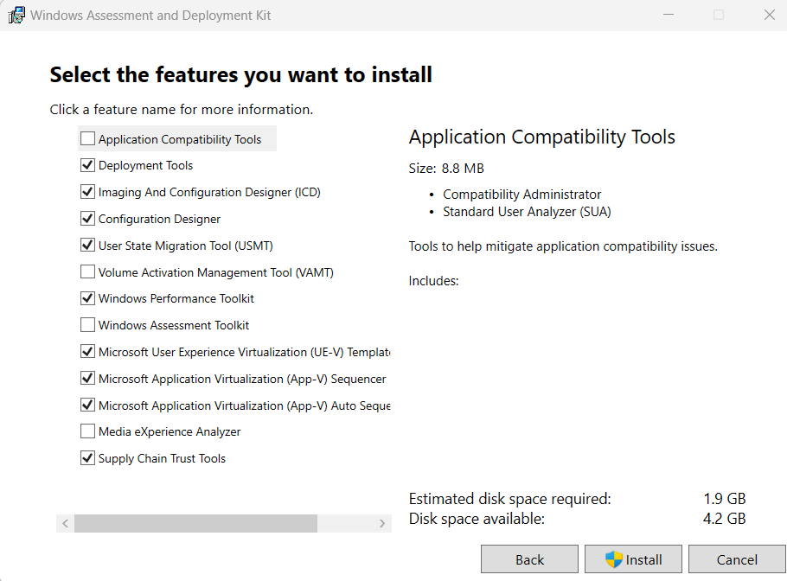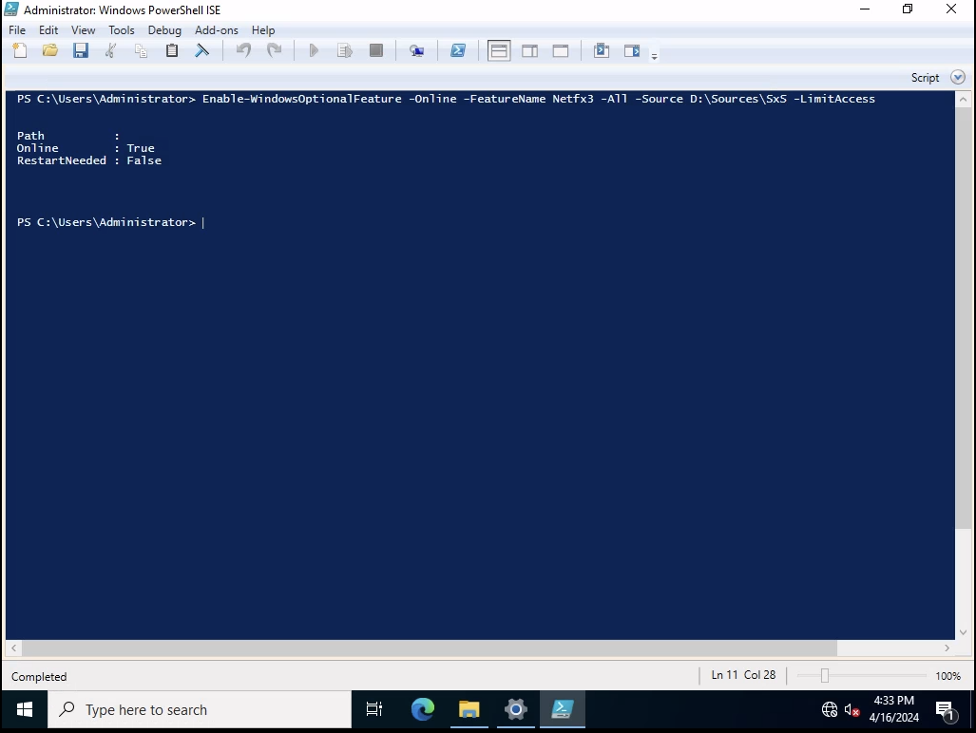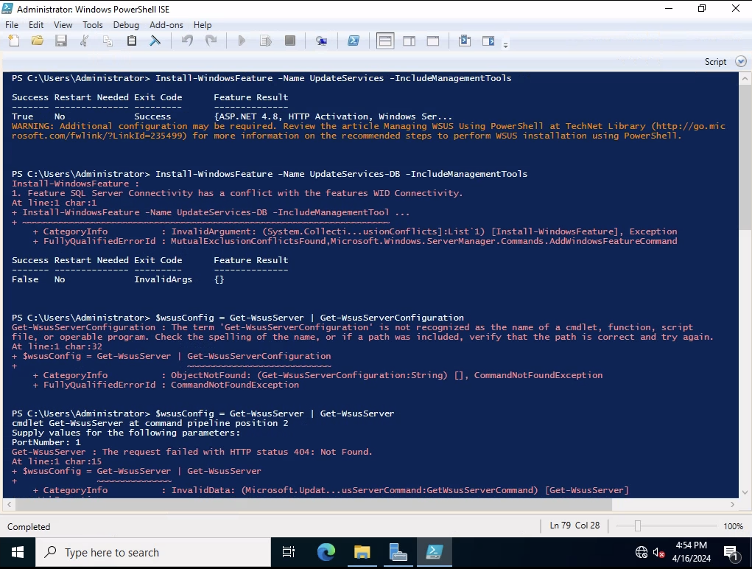

**Summary:**

Configuration management is a crucial systems engineering process aimed at ensuring the consistency of a product’s attributes throughout its lifecycle. This process is vital within enterprise IT infrastructures, where it helps ensure that all system configurations, software deployments, and operational procedures adhere strictly to established policies and practices. Effective configuration management reduces the incidence of unauthorized modifications and mitigates errors, thereby enhancing both system stability and security. The Windows operating system incorporates an extensive suite of integrated tools specifically designed to facilitate this complex process, enabling IT administrators to efficiently manage sophisticated infrastructures.

The security settings within the Windows operating system form the cornerstone of maintaining the integrity and security of enterprise IT environments. At the forefront of these settings is the Windows Defender Security Center, which offers comprehensive protection against a wide spectrum of malware and other security threats. This center includes capabilities such as real-time protection, cloud-delivered protection, and ransomware recovery. These features ensure a resilient defense mechanism against a variety of cyber threats, from viruses to sophisticated ransomware attacks. Additionally, User Account Control (UAC) plays a critical role by requiring administrative privileges for any significant software changes, thus preventing unauthorized modifications that could potentially harm the system. Moreover, the Windows Firewall is crucial for monitoring and regulating both incoming and outgoing network traffic based on predefined security rules. This is vital for preventing unauthorized access and attacks from external sources. Data protection measures are further strengthened by encryption technologies such as BitLocker and BitLocker To Go. BitLocker encrypts the entire drive, providing robust protection against data theft or exposure from lost or stolen devices, while BitLocker To Go extends these encryption capabilities to removable storage devices. Windows Information Protection (WIP) enhances these security protocols by preventing accidental data leaks, and protecting enterprise data on devices from unauthorized access through applications and services. WIP allows IT administrators to define policies that separate personal and organizational data, control which apps have access to organizational data, and even wipe remote data if the device is compromised, all without affecting personal data.

In terms of operating system deployment, Windows offers several robust tools that ensure consistency across devices within an organization, thus supporting overarching configuration management objectives. The Microsoft Deployment Toolkit (MDT) simplifies and automates the deployment process, allowing for the creation of customized installations that include necessary drivers, applications, and configurations. These customized installations can be deployed over networks or via media, facilitating rapid setup of new devices or recovery of existing ones under enterprise standards. Complementing the MDT, Windows Deployment Services (WDS) supports network-based installations, streamlining the deployment process and reducing the manual effort typically required. WDS allows for the deployment of Windows operating systems through network transmissions, eliminating the need for physical media. This capability is especially beneficial in large organizations with a significant number of systems, as it ensures uniformity and compliance with corporate configuration standards. Additionally, the Windows Assessment and Deployment Kit (ADK) is a set of tools used for customizing, assessing, and deploying Windows operating systems to new computers, proving essential during large-scale deployments. For larger enterprises, System Center Configuration Manager (SCCM) provides an even more comprehensive and scalable solution. SCCM facilitates the deployment and management of operating systems, applications, and hardware across an extensive array of devices. It integrates with Microsoft's update service to streamline the patch management process and supports the management of Apple macOS and Linux operating systems, making it a versatile tool for heterogeneous environments. SCCM's ability to manage large-scale deployments of software updates ensures that all devices are maintained up-to-date with the latest security patches and performance improvements.

Patch management is a crucial aspect of maintaining operational integrity and security in Windows operating systems within an enterprise. Windows Server Update Services (WSUS) enables organizations to control the distribution of updates released by Microsoft. WSUS provides a centralized platform from which IT administrators can manage the deployment of updates efficiently, allowing for the selective application of critical updates, service packs, and device drivers. This selective deployment can be crucial for avoiding disruptions in critical systems and for testing updates in limited scenarios before a wider release. Additionally, Windows Update for Business (WufB) streamlines the update process by allowing direct connections to Windows Update services while giving administrators control over the deployment timings and methods. WufB integrates with existing management tools like Group Policy and SCCM to provide a seamless update experience without requiring additional infrastructure. The deployment of applications within Windows is facilitated by tools such as Group Policy, which plays a pivotal role in the centralized management of device and user settings. Group Policy allows for detailed control over the working environment of user accounts and computer accounts, providing comprehensive management of settings in an Active Directory environment. This enables administrators to enforce security policies and to set permissions on a granular level. Furthermore, the Windows Store for Business offers a platform for acquiring, managing, and distributing business applications to Windows 10 devices. This feature supports configuration management by ensuring that only approved applications are installed and maintained within the corporate environment. It allows administrators to tailor the software ecosystem to meet the specific needs of the organization, enhancing both security and productivity.

In conclusion, the Windows operating system offers a robust array of tools supporting all configuration management lifecycle phases. These tools ensure that security, deployment, patch management, and application management are conducted in a manner that upholds the consistency and reliability of system configurations as required in enterprise IT infrastructures. Through these mechanisms, Windows assists in establishing and maintaining the desired state of system configurations over their lifecycle, which is essential for effective configuration management in organizational settings. This comprehensive approach ensures that systems operating on Windows remain secure, reliable, and consistent with enterprise policies and practices, thereby reinforcing the infrastructure’s overall efficacy and security.